Landings of Sphyrna zygaena (Linnaeus, 1758) in northern Peru indicate overfishing.
Katicsa Natalie De La Cruz Barrueto¹, Kenyi Kaneshima González¹, Zoila Gladis Culquichicón Malpica^{2*}, Alvaro Edmundo Tresierra Aguilar² and Bilmia Veneros Urbina²
1. Professional School of Fisheries Biology, Universidad Nacional de Trujillo, Trujillo, Perú
2. Department of Fisheries, Universidad Nacional de Trujillo, Trujillo, Perú.
* Corresponding author: zculquichiconm@gmail.com, Universidad Nacional de Trujillo, Av. Juan Pablo II, S/N, Trujillo, La Libertad, Perú.

Short Title: Sphyrna zygaena population in Peru.

Abstract
A commercial fishery for the smooth hammerhead shark Sphyrna zygaena exists in the waters off northern Peru. Although this species is regulated by international and domestic norms, the population continues to decrease. To understand the present state of the fishery, we made monthly visits to four ports in the La Libertad region to measure S. zygaena landings. Our census resulted in troubling observations: nearly all landed specimens were juveniles or younger and the fishery is being overexploited with only 10% of biomass remaining. This highlights that stronger regulations to protect breeding areas and limit catch are urgently required for a sustainable fishery.
Keywords
Sphyrna zygaena, smooth hammerhead shark, fisheries management, population structure, overfishing, Peru
Introduction
The smooth hammerhead shark (Sphyrna zygaena (Linnaeus, 1758)) is a highly migratory species that is usually found near the coast of South America, from the Caribbean north to Nova Scotia, Europe, and Africa (UN, 2019). The coasts of northern Peru provide a good habitat for S. zygaena, where it reproduces in estuaries and feeds on Humboldt and common squid (Dosidicus gigas [d’Orbigny, 1835], Doritheuthis gahi [d'Orbigny, 1835]) (Gonzalez-Pestana, et al., 2017).
Peru is a commercial exploiter of S. zygaena (Gonzalez-Pestana et al., 2016), where it is known and consumed locally as "tollo". The fishery is regulated by the Peruvian government, which prohibits extraction between 1 January and 10 March annually (Ghezzi Solís, 2016) and has also temporarily restricted the size of the catch (Chicoma Lúcar, 2021). The reproductive biology of S. zygaena and other sphyrnids makes them sensitive to overfishing because they grow slowly, mature at a late age, and have a low natural rate of increase. For this reason, all Sphyrna spp. are listed in Appendix II of the Convention on International Trade in Endangered Species of Wild Fauna and Flora (CITES) treaty, and eight spyrnids are listed as vulnerable, threatened, or endangered by the International Union for Conservation of Nature (IUCN). Currently, S. zygaena is listed as vulnerable with a decreasing population by the IUCN (Gonzalez-Pestana, et al., 2016; CITES, 2023; IUCN, 2023).
Because maintaining sustainable fisheries is based on data-driven cooperation between policymakers, law enforcement, and marine biologists, we report on the population and size distribution of S. zygaena landings in the La Libertad region of Perú in order to understand the current population dynamics of this species.

Materials and Methods
Between March and September 2022, once-monthly surveys were conducted of the fishing ports of Pacasmayo (7° 23' 53" S, 79° 34' 16" W), Puerto Malabrigo (7° 41' 46" S, 79° 26' 10" W), Salaverry (8° 13' 26" S, 78° 58' 52" W), and Puerto Morín (8° 23' 56" S, 78° 53' 49" W), all located in the La Libertad region of northern Peru. Landed specimens of S. zygaena were identified according to Romero Camarena (2018) and were both intact and headless. Headless specimens were measured from the fifth gill slit to the tip of the caudal fin (headless length, HL), while intact specimens were measured from the tip of the snout to the tip of the caudal fin (total length, TL).
To correlate HL and TL, photos and intact specimens of S. zygaena were examined. This correlation was used to estimate TL for headless specimens.
To determine population statistics, the TL of the observed landings with a histogram interval of 3 cm was inputted into the FISAT II computer program (FAO, 2023). The program was used to calculate growth constants, recruitment pattern, growth curves, mortality constants, estimation of mean catch size, variation of the instantaneous rate of fishing mortality according to length, relative yield per recruit, and biomass per recruit. The Shapiro-Wilk test for normality, Tukey´s fence for outliers, and the Mann-Whitney U test were used on TL data, with a statistical significance level of p<0.05.

Results
In Pacasmayo, surveys in March and April yielded 4 and 62 S. zygaena specimens, respectively. In Salaverry, the largest fishing port in La Libertad, surveys in May, June, July, and September yielded 159, 63, 17, and 2 S. zygaena specimens, respectively. All other surveys yielded no specimens.
To correlate HL and TL, photos of S. zygaena were analyzed; this was validated by observation of four landed specimens. The regression used for the study showed that HL predicted TL, R²=0.85, β = 1.37, α = -1.24. This formula was used to calculate the TL for all headless landed specimens.
Salaverry TL ranged from 63 to 186 cm, with a median of 92 cm and a skew toward smaller specimens (Shapiro Wilk, p<0.0001). The longest TL qualifies as an outlier using Tukey's fence. Pacasmayo TL ranged from 63 cm to 121 cm with a median of 79.5 cm. Like Salaverry, there was a skew toward smaller specimens (Shapiro Wilk, p <0.0001). Combining all TL data from the study, we observe a skew toward smaller specimens (Shapiro Wilk, p < 0.0001): most specimens were between 83 and 119 cm with a median of 90 cm and a mode of 84 cm, when rounding to the nearest cm.
Although there was a statistically significant difference in TL between ports (Mann-Whitney U, p < 0.0001), population statistics were calculated on combined fishery data. This is because the species is highly mobile (UN, 2019), the catches were in different months for different ports, fishing locations change, fishing boats sometimes do not depart from the same port they left, and the two ports were rather close together. Thus, it is likely that the same fishery was being sampled.
To visualize landed S. zygaena TL, we created a histogram (Figure 1). Upon inspection of the data, six age groups were determined (peaks of the red line; Bhattacharyya, 1967). From these data, it was also possible to calculate additional population statistics, using FiSAT II (FAO, 2023), which are outlined in Table 1.
FiSAT II was also used to calculate several other parameters for the fishery in northern Peru. The length and weight growth equations were calculated. From these curves, we observe that S. zygaena length increases at rapidly until reaching an inflection point at approximately 1 year of age, where length increase tapers off through the juvenile and adult stages. The weight growth curve has two inflection points, one at 1 year and another at 5 years. Rapid weight gain occurs between 1 and 5 years of age (Figure 2). Breeding occurs in February and the recruitment pattern has two pulses, the largest of which occurs between May and July, with a small peak in September (Figures 3 and 4). The natural mortality rate (M, 0.47/year) was calculated using the von Bertalanffy formula, assuming a temperature of 16º C.
Furthermore, statistics on the state of the fishery were calculated. The total mortality rate (Z) was estimated to be 2.134/year, with a confidence interval from 2.000 to 2.269 (Jones and van Zalinge, 1981). The difference between Z and M gives the fishing mortality, F, which is 1.66/year. The L₂₅, L₅₀ and L₇₅ probabilities of capture are 90.62, 101.81, and 113 cm, respectively (Figure 5). We also find that this mortality is not distributed evenly along lengths (Figure 6), with highest F occurring near maximum length and between 85 to 91 cm. The yield isopleth (Figure 7) was used to estimate an exploitation rate of 0.8. Applying this rate to the relative yield per recruit plot (Figure 8), we calculate the maximum sustainable yield at an exploitation rate of 0.69, an optimal yield of 0.60, and critical biomass at an exploitation rate of 0.37. Furthermore, the biomass curve indicates that 10% of the original biomass remains.
Discussion
Although S. zygaena is included in the CITES treaty, which should provide some protection, it is nonetheless being overexploited (Figures 5 and 8). This makes S. zygaena vulnerable to continued population decrease because of fishing (Tresierra & Culquichicón, 1993).
An additional observation supporting this assertion is that over the entire study period, not a single specimen in excess of 200 cm was landed, which is the minimum length for sexual maturity (Castañeda, 2001; Nava and Márquez, 2014). Therefore, currently, the fishery is mostly composed of neonates and juveniles. This was not the case for a study at the turn of the century in which specimens as large as 340 cm were observed (Castañeda, 2001; Nava and Márquez, 2014). A subsequent study in Peru published in 2021 observed a maximum length of 294 cm (Acuña, 2021). These previous samplings also observed a skew toward smaller specimens. Taken together with the present work, data suggest a steady decline to near elimination of sexually mature S. zygaena in this fishery over the past two decades.
Because of the absence of longer specimens in the present study, the population statistics in Table 1 may be biased to underestimate L∞, and overestimate k. A report on S. zygaena in Baja California calculated L∞ of 349 cm and k of 0.16 for females, and an L∞ of 338 cm and k of 0.18 for males, for instance (Morán Villatoro, 2018). Other research on Sphyrna spp. shows a similar trend, with L∞ between 220 and 350 cm, k between 0.11 and 0.18, and t₀ between -2.86 and -0.63 years (Anislado and Robinson, 2001; Piercy, et al., 2007; Piercy, et al., 2010; Zarate Rustrián, 2010). Our results, although not likely applicable to understanding the natural growth of S. zygaena, nonetheless highlight the overexploitation of the species in northern Peruvian waters and how population statistics can be misleading without including of fishing mortality.
S. zygaena was landed at only two of the four ports studied. There are three likely reasons for this. First, Morín and Malabrigo are have smaller fleets, with Salaverry accounting for about half of total catch in the La Libertad region. Second, other authors have also suggested that this is due to seasonal migration of S. zygaena to cooler waters in summer and warmer waters in winter, which bypassed Morín and Malabrigo, as long-duration La Niña conditions in the Pacific Ocean dominated between September and mid-November 2022 (NOAA, 2023). Third, personal communication with the fishers from the four ports indicated that 2022 was a poor year for fishing. Fishers in Puerto Morín migrated north, and those in Puerto Malabrigo focused on other species.
Landings of S. zygaena were not evenly spread throughout the study period; more than half of the specimens studied were landed in May. This result nicely coincides with previous work between 2017 and 2019 as the yearly maximum for S. zygaena landings occurred in April, May, or June. These months also coincide with maximum recruitment (Figure 4). These results may be explained by climatic patterns off the northern Peruvian coast. During the austral winter, the Pacific anticyclone creates strong winds that flow principally from the south that then veer westward, which strengthens an upwelling of nutrients that enriches the food chain, enabling predators, like S. zygaena, to grow rapidly during these months. It is also likely that this yearly cycle is responsible for the February breeding season, which positions neonates to take advantage of this abundance.
S. zygaena has a high natural rate of M, which must be considered for management plans (Gimenez, 2001). One possible way to decrease M could include better management of estuaries, bays, and mangroves where S. zygaena commonly rears its young, where the turbid, nutrient-rich water offers food and protection to neonates and juveniles (Zanella, et al., 2009).
Conclusions
Despite legal protections and legal regulation, S. zygaena is an overexploited species in northern Peruvian waters, putting continued commercial exploitation of this species at risk. To reestablish a balance between recruitment and exploitation, additional measures that reduce natural and fishing mortality should be taken. These actions may include protecting estuaries where young are found, limiting catch mass, and placing further limitations on the fishing season.
Data availability statement
A spreadsheet containing the TL, month, and location of the sharks examined in this study is available as a supplemental data set.
Acknowledgment
The authors wish to acknowledge help from IMARPE field observers German Vela, Cinthia Vásquez Ruiz, and Armando Isla.
This research did not receive any specific grant from funding agencies in the public, commercial, or not-for-profit sectors.
The authors have no conflicts of interest, financial or otherwise in the publication of this manuscript.
Authorship
Katicsa Natalie De La Cruz Barrueto: Formal analysis, Investigation, Writing – Original draft, Writing – Review and editing, Data Curation. Kenyi Kaneshima González: Investigation, Writing – Original draft, Writing – Review and editing, Data Curation. Zoila Gladis Culquichicón Malpica: Conceptualization, Funding acquisition, Formal analysis, Methodology, Project Administration, Resources, Supervision, Writing – Review and editing. Alvaro Edmundo Tresierra Aguilar: Funding acquisition, Methodology, Resources, Validation. Bilmia Veneros Urbina: Funding acquisition, Methodology, Resources.
References
Acuña, N. 2021. Ecología trófica del “tiburón martillo” Sphyrna zygaena (Linnaeus, 1758) (Carcharhiniformes: Sphyrnidae), en el norte del Perú. Bachelor Thesis, Universidad Ricardo Palma, Lima, Perú. [https://repositorio.urp.edu.pe/handle/20.500.14138/4411]. Reviewed: May 7, 2023.
Anislado, V. and Robinson, C. 2001. Edad y crecimiento del tiburón martillo Sphyrna lewini (Griffith y Smith, 1834) en el Pacífico central de México. Ciencias Marinas, 27(4), 501-520. [https://www.redalyc.org/comocitar.oa?id=48027402]. Reviewed: July 7, 2023.
Bhattacharyya, C. G. 1967. A simple method of resolution of a distribution into Gaussian components. Biometrics, 23, 115-35. doi: 10.2307/2528285.
Castañeda, J. 2001. Biología y Pesquería del “Tiburón Martillo” (Sphyrna zygaena) en Lambayeque, 1991 – 2000. Laboratorio Costero de Chiclayo – IMARPE. Informe Progresivo. Nº 139. [https://biblioimarpe.imarpe.gob.pe/bitstream/20.500.12958/1282/1/IP%20139.2.pdf]. Reviewed: May 7, 2023.
Chicoma Lúcar, J.L. 2021. Establecen límite de captura del recurso tiburón martillo, correspondiente al período 2021 RESOLUCIÓN MINISTERIAL Nº 00104-2021-PRODUCE. El Peruano. [https://busquedas.elperuano.pe/download/url/establecen-limite-de-captura-del-recurso-tiburon-martillo-c-resolucion-ministerial-no-00104-2021-produce-1941312-1]. Reviewed: May 7, 2023.
CITES. 2023. Appendices I, II, and III of the convention on international trade in endangered species of wild fauna and flora. [https://cites.org/eng/app/appendices.php]. Reviewed May 7, 2023.
FAO. 2023. Fisheries and Aquaculture - Fisheries and Aquaculture - FISAT II - FAO-ICLARM Stock Assessment Tool. [https://www.fao.org/fishery/en/topic/16072/en]. Reviewed: May 7, 2023.
Gonzalez-Pestana, A., Kouri, C., Velez-Zuazo, X. 2016. Shark fisheries in the Southeast Pacific: A 61-year analysis from Peru. F1000Research. 3, 164. doi: 10.12688/f1000research.4412.2
Gonzalez-Pestana, A., Alfaro-Shigueto, J., Mangel, J. C., Espinoza, P. 2017. Mercury levels in the smooth hammerhead shark Sphyrna zygaena (Carcharhiniformes: Sphyrnidae) from northern Peru. Revista Peruana de Biología. 24(4), 407-411. doi: 10.15381/rpb.v24i4.14066
Ghezzi Solís, P.E. 2016. Establecen temporada de pesca del recurso tiburón martillo a nivel nacional: RESOLUCIÓN MINISTERIAL Nº 008-2016-PRODUCE. [https://busquedas.elperuano.pe/download/url/establecen-temporada-de-pesca-del-recurso-tiburon-martillo-a-resolucion-ministerial-no-008-2016-produce-1333838-1] Reviewed: May 7, 2023.
Giménez, E., Delgado, G., Alfonso, S., Gil, O. 2011. Estimación de la tasa de mortalidad natural y por pesca de Farfantepenaeus notialis (Pérez-Farfante, 1967) en el período 1995- 2009 del Golfo de Ana María, Cuba. Boletín del Centro de Investigaciones Biológicas, 45(3), 287-298. [https://produccioncientificaluz.org/index.php/boletin/article/view/298]. Reviewed: July 7, 2023.
IUCN, 2023. IUCN red list of threatened species. [https://www.iucnredlist.org/]. Reviewed: May 7, 2023.
Jones, R. and van Zalinge, N.P. 1981. Estimations of Mortality Rate and Population Size for Shrimp in Kuwait Waters, Kuwait Bulletin of Marine Science, 2, 273-288.
Mendoza Treviño, A., 2018. Evaluación de riesgo ecológico por efectos de la pesca del tiburón martillo Sphyrna lewini (Griffith & Smith, 1834) en el sur del Golfo de México. Master’s Thesis. Universidad Nacional Autónoma De México, Mexico City. [http://132.248.9.195/ptd2018/junio/0775818/0775818.pdf]. Reviewed: July 7, 2023
Morán Villatoro, J.M., 2018. Edad y crecimiento del tiburón martillo Sphyrna zygaena (Linnaeus, 1758) en la costa occidental de Baja California Sur. Master’s Thesis, Instituto Politécnico Nacional, La Paz, Baja California, México.
Nava, N.P. and Márquez-Farías J.F., 2014. Talla de madurez del tiburón martillo, Sphyrna zygaena, capturado en el Golfo de California. Hidrobiológica 24(2), 129-135.
NOAA, 2023. MEI.v2: NOAA Physical Sciences Laboratory. [https://psl.noaa.gov/enso/mei/]. Reviewed: May 8, 2023.

Piercy, A. N., Carlson, J. K. and Passerotti, M. S. 2010. Age and growth of the great hammerhead shark, Sphyrna mokarran, in the north-western Atlantic Ocean and Gulf of Mexico. Marine and Freshwater Research, 61(9), 992-998. doi: 10.1071/MF09227.
Romero Camarena, M., 2018. IMARPE: Manual para identificación de troncos de tiburones de importancia comercial en el Perú. [https://repositorio.imarpe.gob.pe/handle/20.500.12958/3305]. Reviewed: May 7, 2023.
Tresierra, A. and Culquichicón, Z., 1993. Biología Pesquera. Editorial Libertad, Trujillo, Perú.
UN, 2019. Proposal for the Inclusion of the Smooth Hammerhead Shark in Appendix II of the Convention | CMS. [https://www.cms.int/en/document/proposal-inclusion-smooth-hammerhead-shark-appendix-ii-convention-1]. Reviewed: May 7, 2023.
Zarate Rustrián, J. 2010. Edad y Crecimiento del tiburón martillo Sphyrna lewini (Griffith & Smith, 1834) en la Costa Sur de Oaxaca, México. Master’s Thesis, Instituto Politécnico Nacional La Paz, Baja California, México. [http://tesis.ipn.mx/handle/123456789/19345]. Reviewed: July 7, 2023.
Zanella, I., López-Garro, A., Arauz, R., 2009. Characterization of the fishing of the hammer shark Sphyrna lewini, in the external part of the Gulf of Nicoya, Costa Rica. Journal of Marine and Coastal Sciences, 1, 175-195. doi: 10.15359/revmar.1.10.
Tables
Table 1. Population statistics of S. zygaena in the La Libertad region of Peru. These statistics were determined using the FiSAT II program. L∞ is the asymptotic total length, k is the constant growth rate, t₀ is the age at which fish length is calculated to be zero, R_{n} is the number of modes used in the growth curve divided by the total number of modes, and W∞ is the asymptotic total mass, calculated from L∞ using a = 0.0000016 and b = 3.2.

Parameter | Value with units
L∞ | 196 cm
k | 0.43/year
t₀ | -0.23 years
R_{n} | 0.277
W∞ | 34.5 kg

Figures
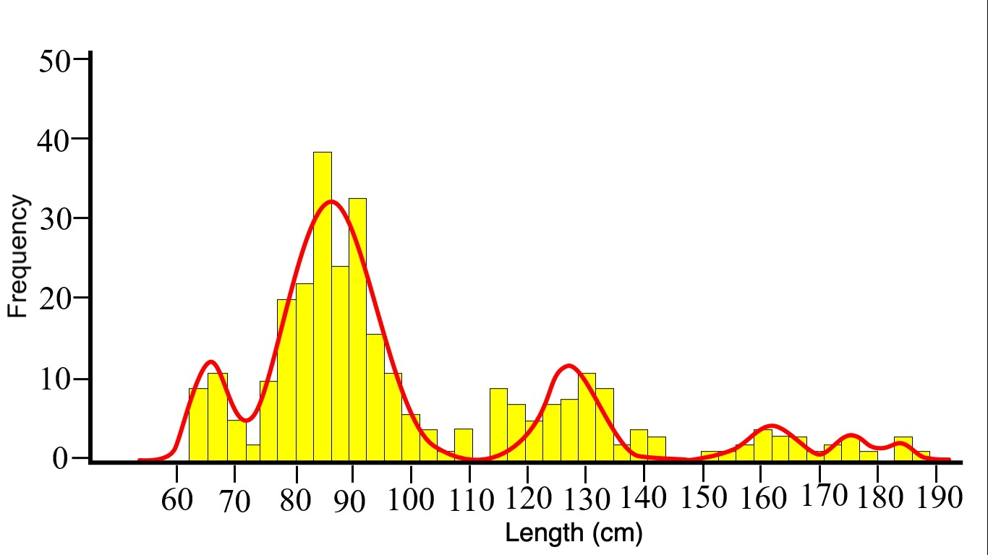

Figure 1. Histogram of S. zygaena TL landed between March and September 2022 in Pacasmayo and Salaverry. Bin width is 3 cm. The histogram skews toward smaller specimens. Using the method described by Bhattacharyya (1967), 6 different population groups are observed (red lines).

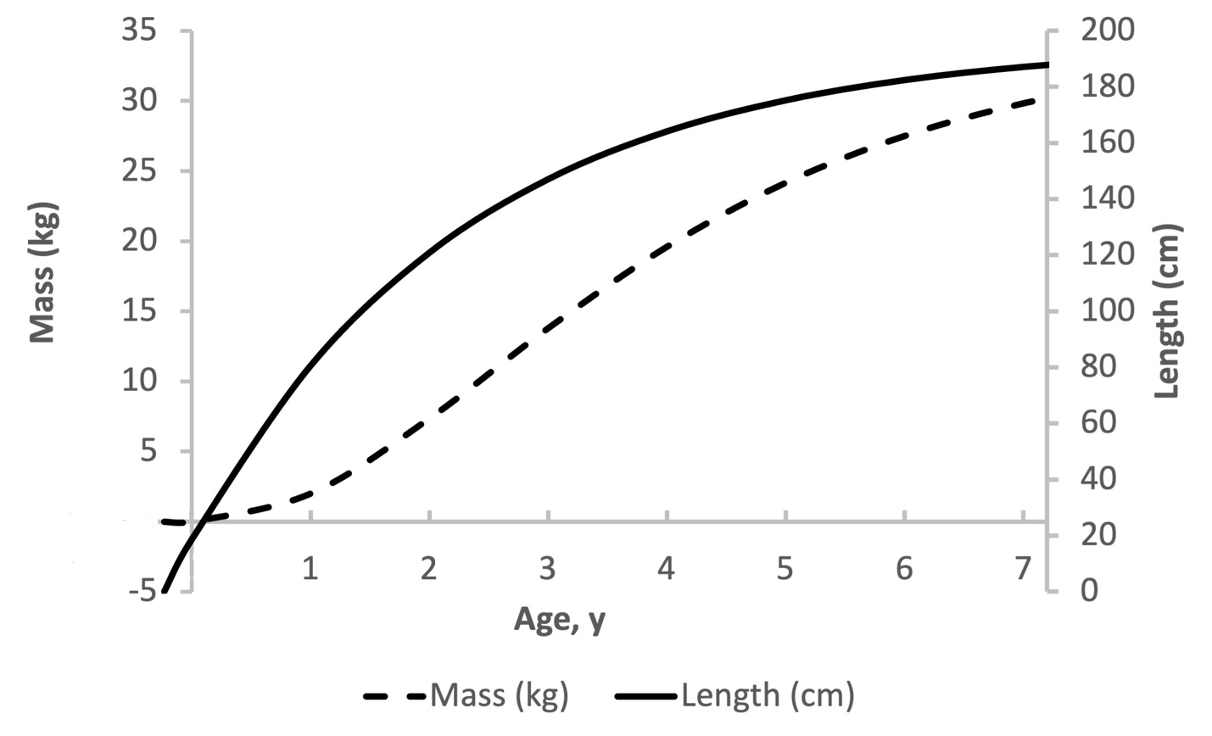

Figure 2. Growth curves for length (solid line) and mass (dashed line) for S. zygaena. Growth curves were calculated using von Bertalanffy’s growth equations for length and weight, using the results in Table 1. The equation for length is $L=196\left(1-e^{-0.43\left(t+0.23\right)}\right)$. The equation for mass is $M=34.5{\left(1-e^{-0.43(t+0.23)}\right)}^{3.2}$.

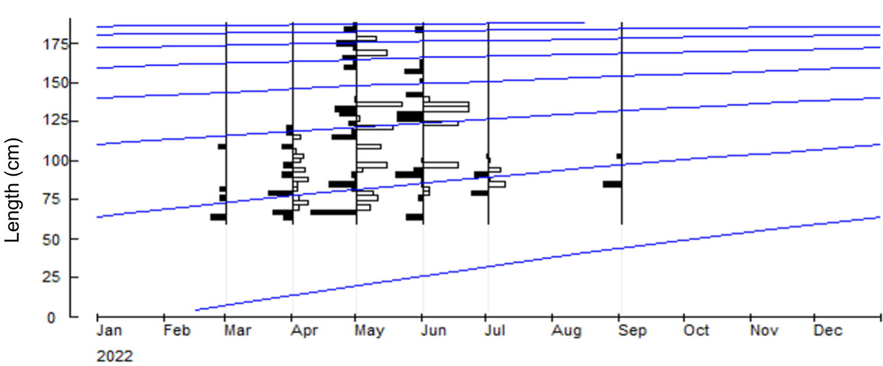

Figure 3: Growth curve by length of S. zygaena using ELEFAN I routines of the FiSAT II program.

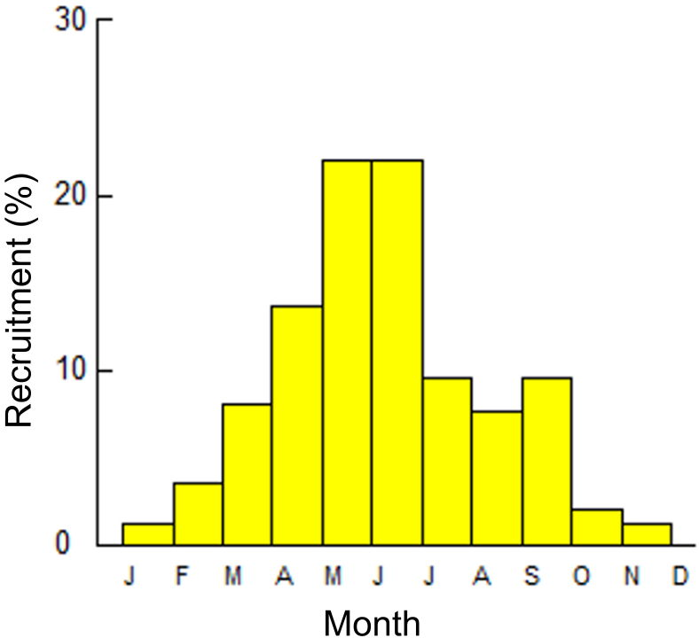

Figure 4: S. zygaena recruitment pattern.

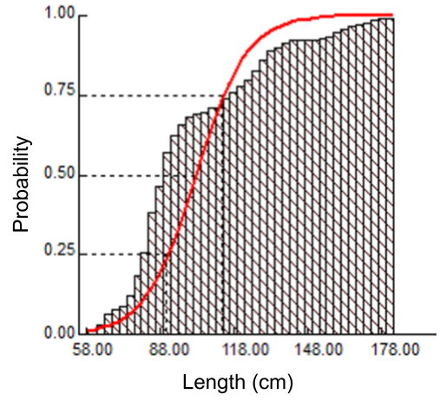

Figure 5. Probability of capture of S. zygaena as a function of TL.

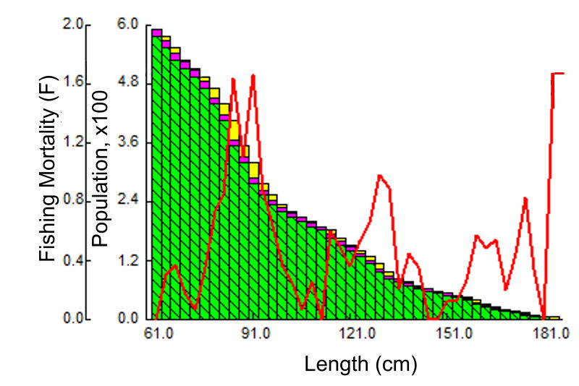
Figure 6. Mortality vs total length for S. zygaena. Natural mortality (purple), fishing mortality (yellow), and remaining survivors (green) is represented for each length class. Fishing mortality according to length is also represented by the red line.

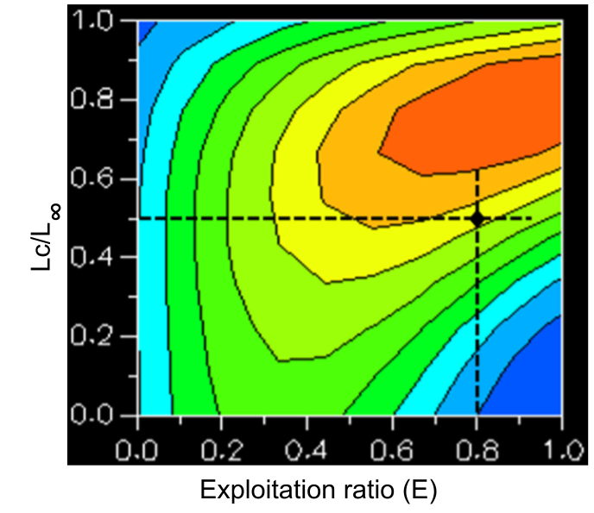
Figure 7: Yield isopleth plot for S. zygaena.

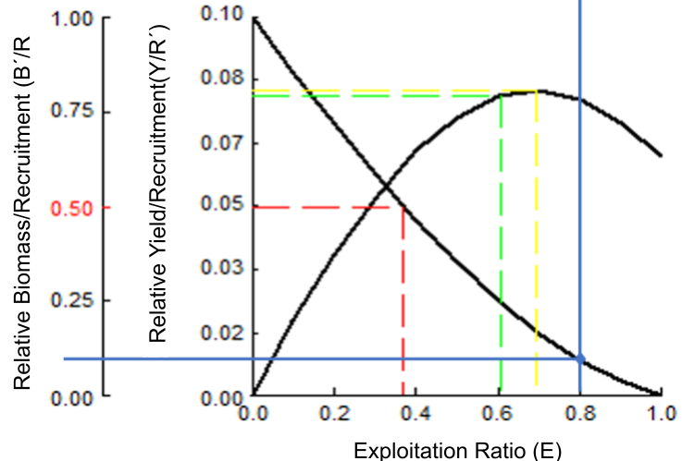

Figure 8: Beverton and Holt’s relative yield per recruit and average biomass per recruit model for S. zygaena. E10 (green line), E50 (optimal sustainable yield, red line), and Emax (maximum sustainable yield, yellow line) are included. The blue line indicates the current situation.

