Marine animal forests from temperate mesophotic ecosystems of Central Chile
Supplementary Figures
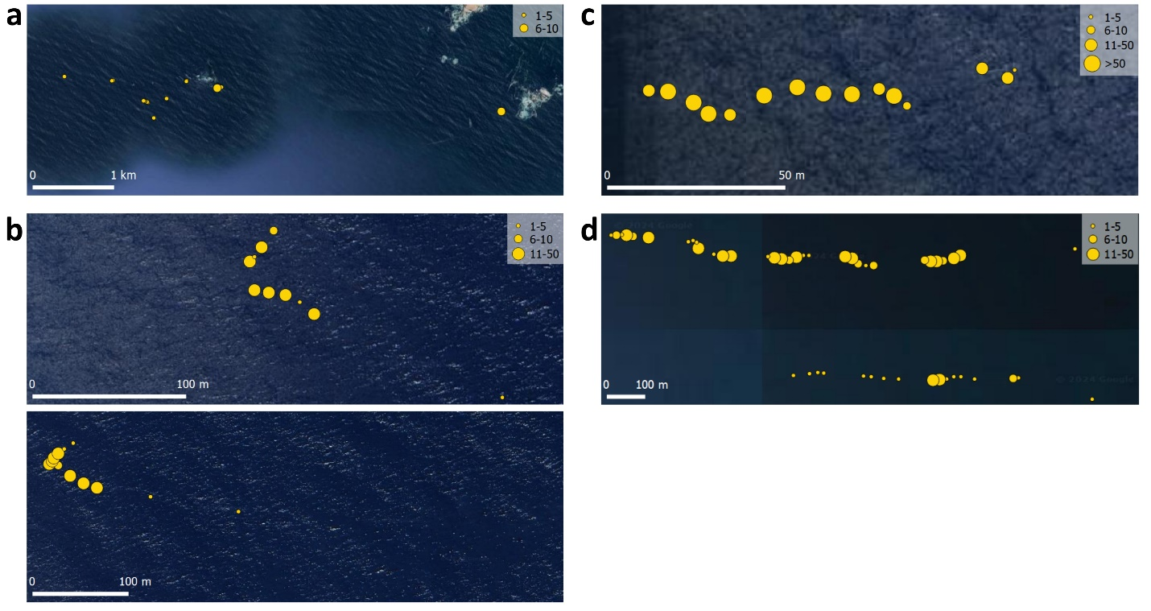
Supplementary Figure 1. Detail of the distribution of Axinella sp. The number of individuals on each video interval is proportional to the size of the circles as the legends show in the top right. The detailed view of Los Vilos is shown in (a), Algarrobo in (b), El Quisco in (c), and Las Cruces in (d).
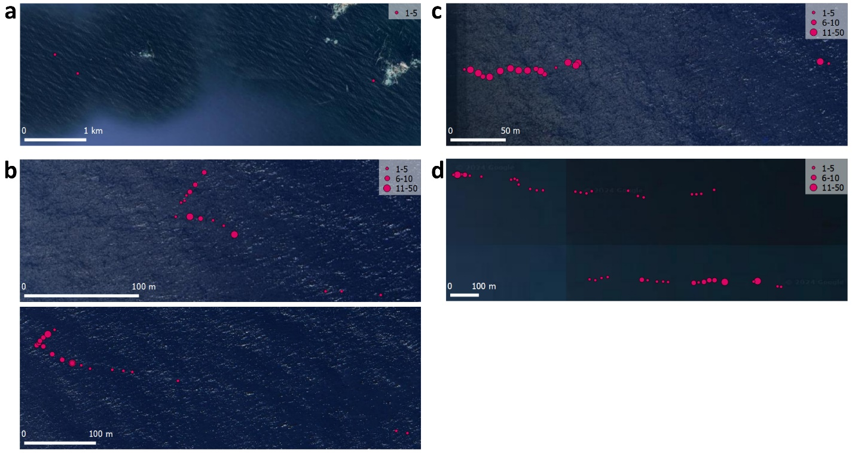
Supplementary Figure 2. Detail of the distribution of Leptogorgia chilensis. The number of individuals on each video interval is proportional to the size of the circles as the legend shows in the top right. The detailed view of Los Vilos is shown in (a), Algarrobo in (b), El Quisco in (c), and Las Cruces in (d).

